**NAME: B.NITHESH KUMAR**

**REGNO: 192011035**

**1.USE CASE DIAGRAM:**

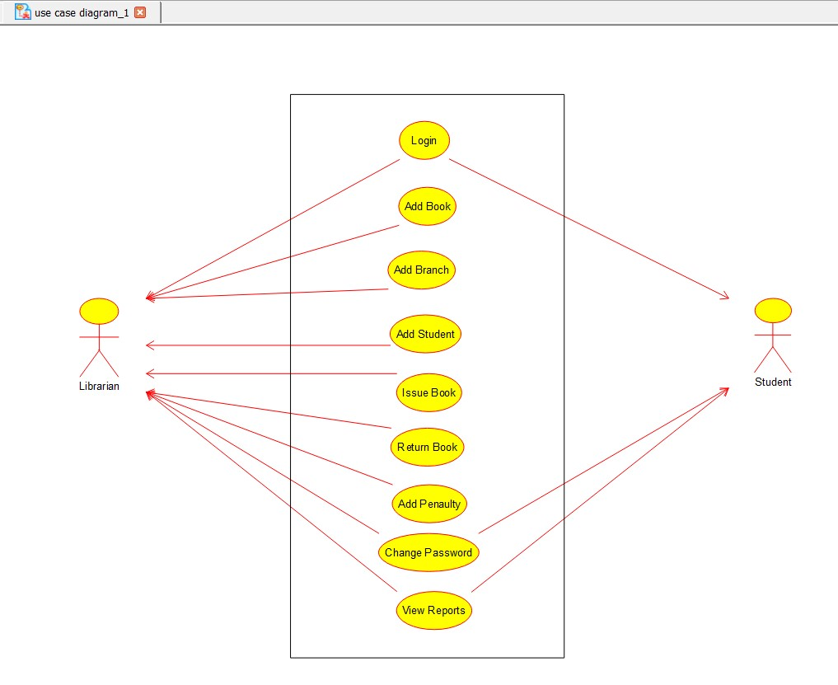

**2. SEQUENCE DIAGRAM:**

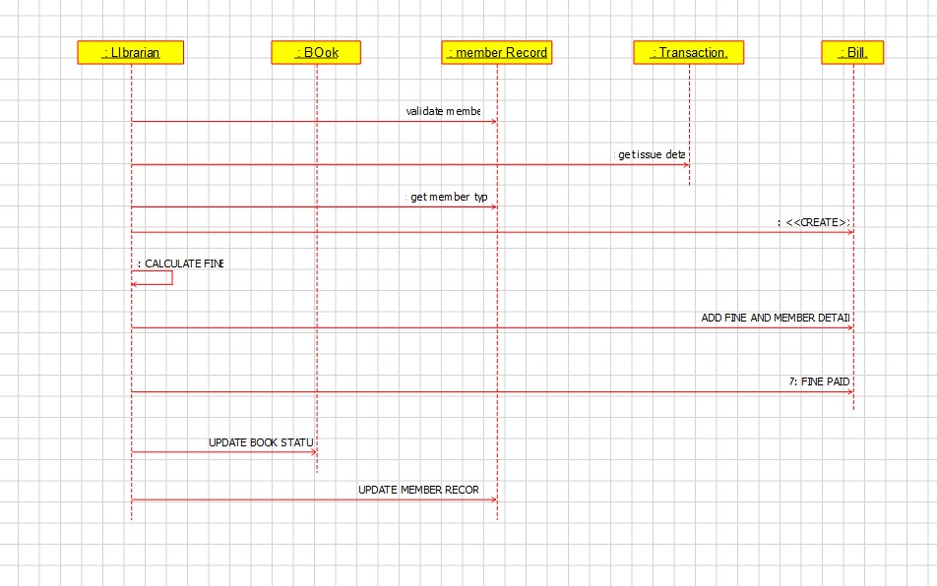

**3.CLASS DIAGRAM:**

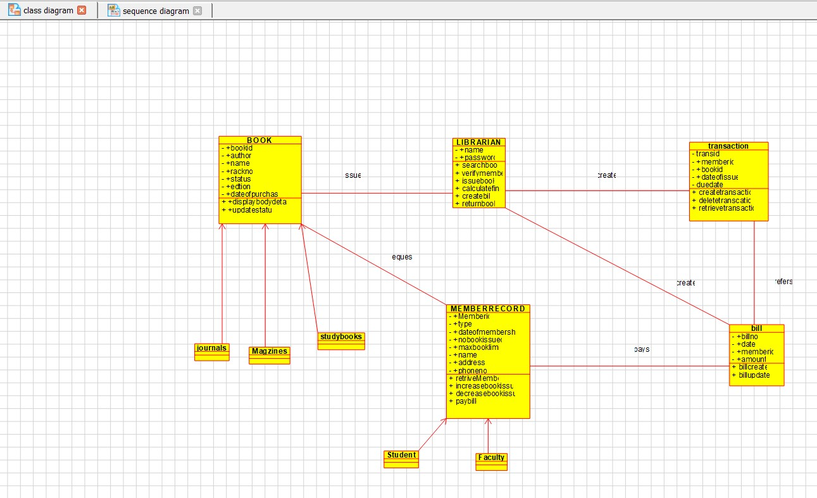

**4.ACTIVITY DIAGRAM:**

